Fractions-Questions
Key Stage 3: 2003 Paper 1 Level 5-7
1.
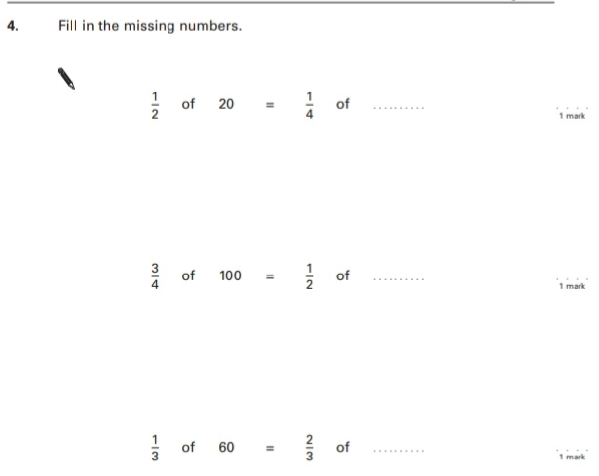
2.
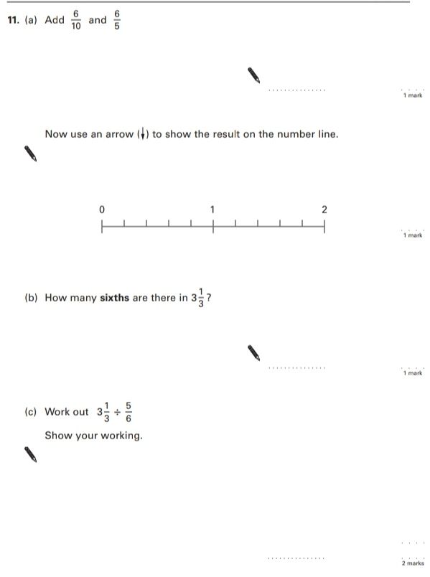
Key Stage 3: 2003 Paper 2 Level 5-7
3.

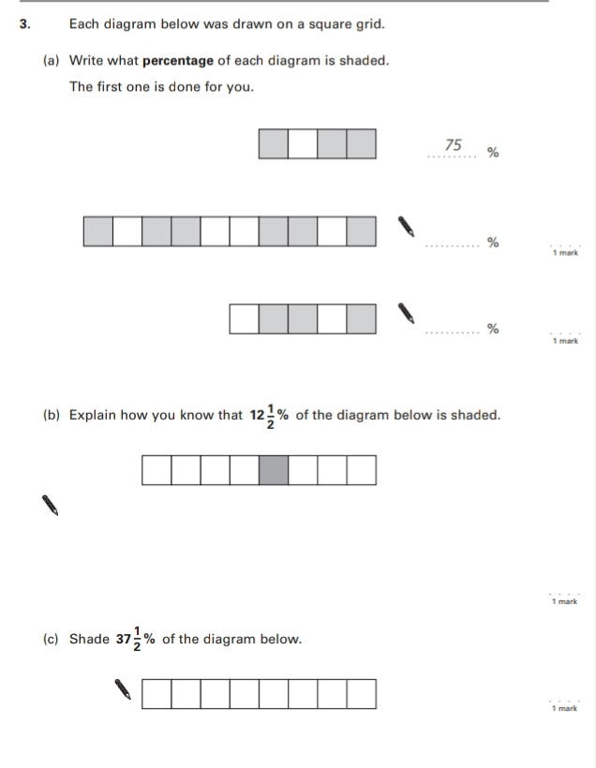

4.
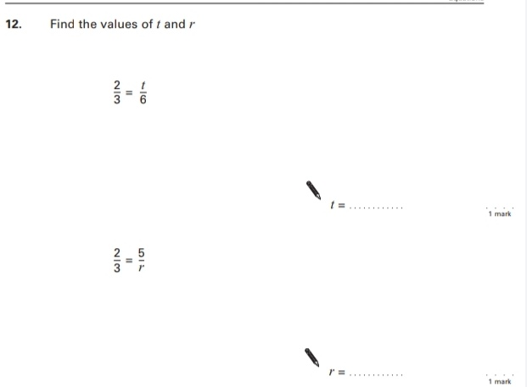

Key Stage 3: 2003 Paper 1 Level 6-8
5.
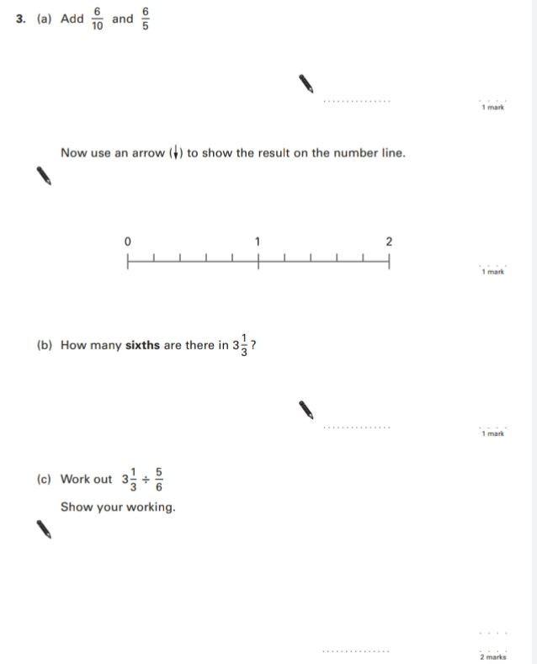
6.
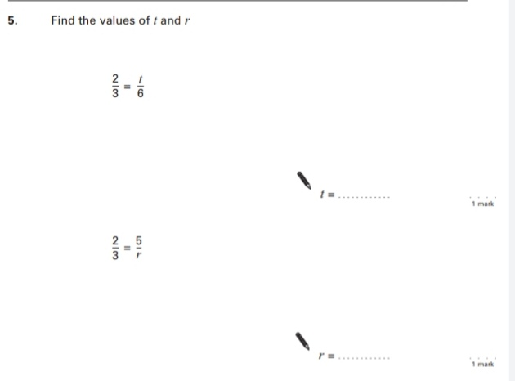
Key Stage 3: 2004 Paper 1 Level 5-7
7.
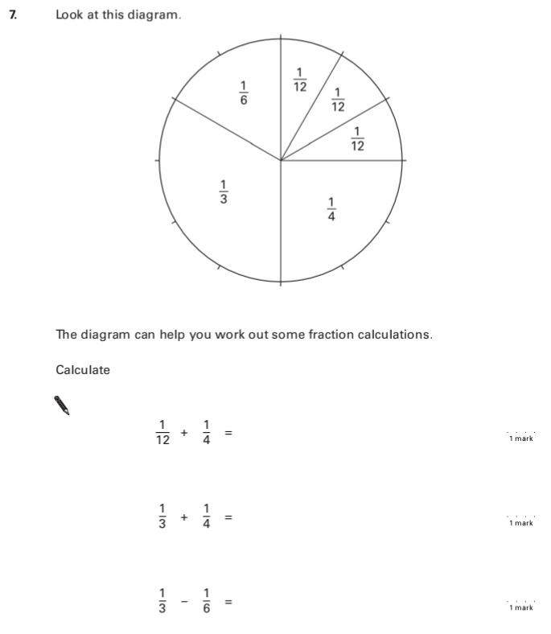
8.
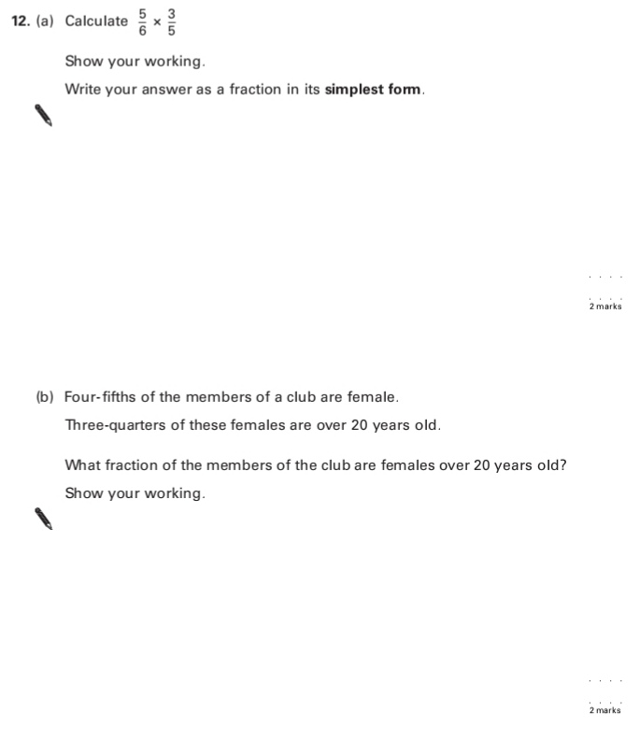
9.
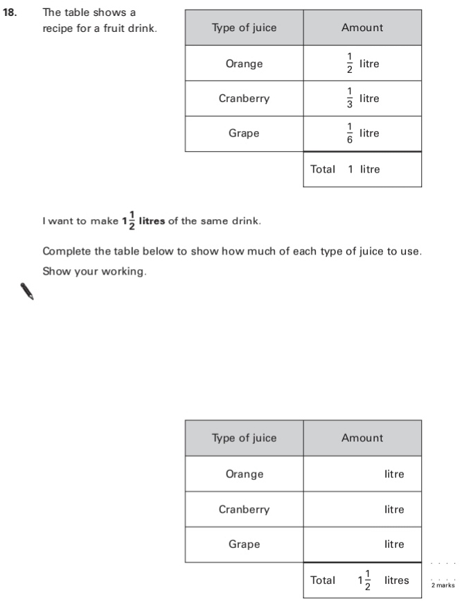
Key Stage 3: 2004 Paper 1 Level 6-8
10.
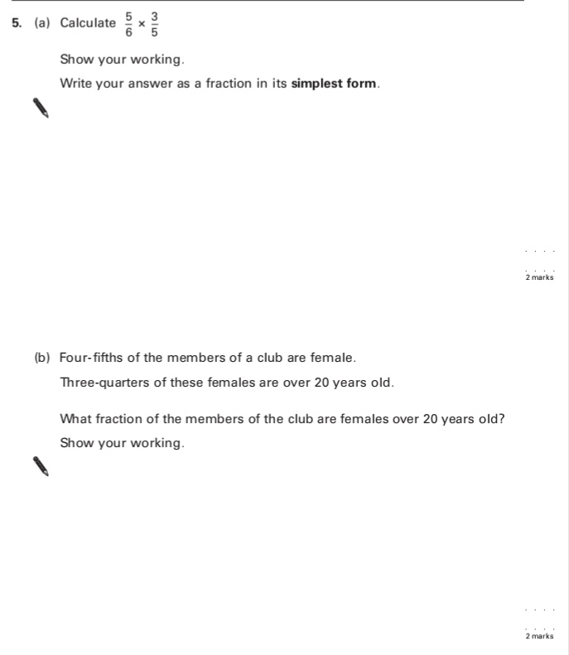
11.
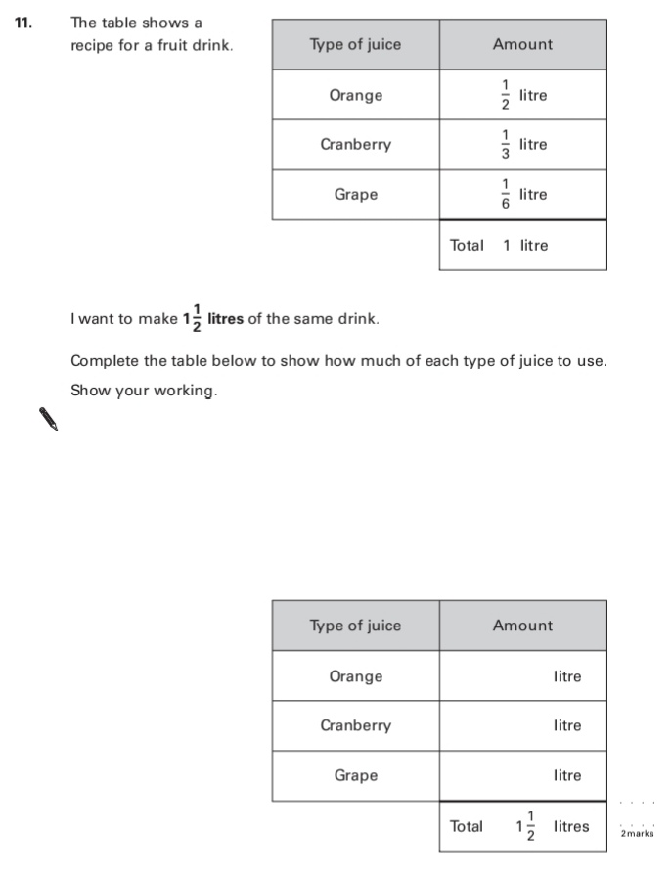
Key Stage 3: 2005 Paper 1 Level 5-7
12.
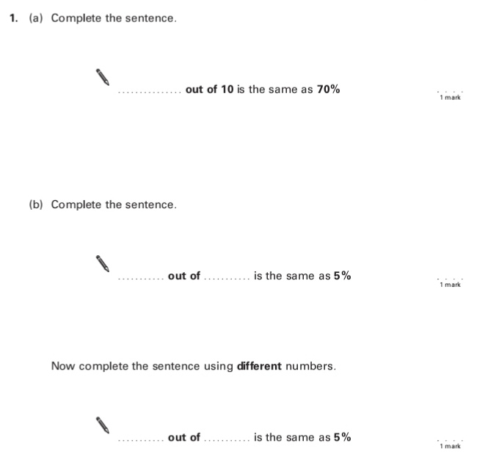
13.
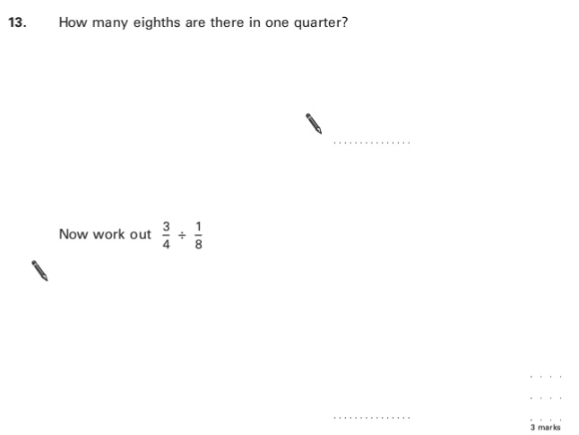
14.
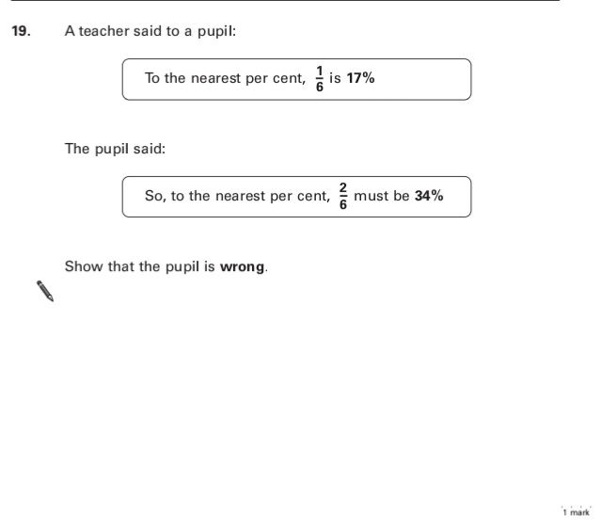
Key Stage 3: 2005 Paper 1 Level 6-8
15.
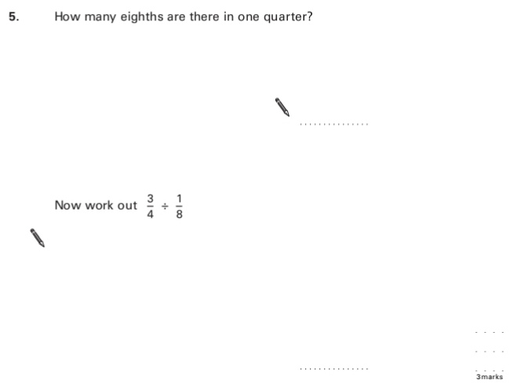
Key Stage 3: 2005 Paper 1 Level 6-8
16.
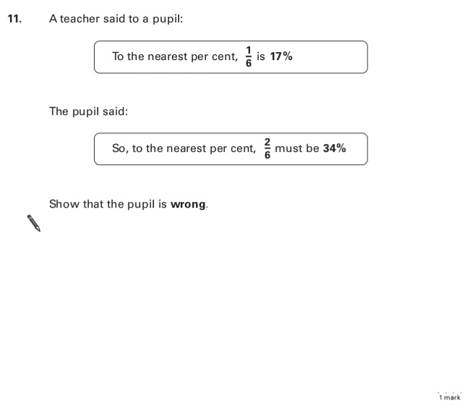
Key Stage 3: 2006 Paper 1 Level 5-7
17.
Key Stage 3: 2006 Paper 1 Level 6-8
18.
Key Stage 3: 2007 Paper 1 Level 5-7
19.
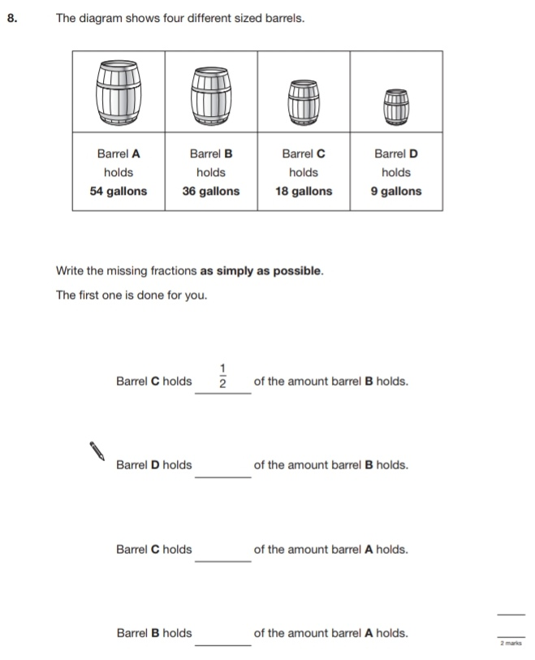
20.
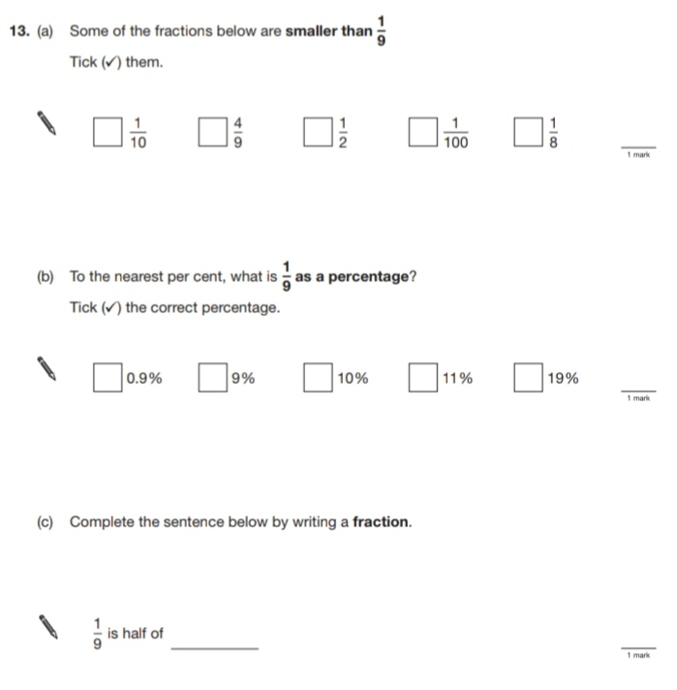
21.
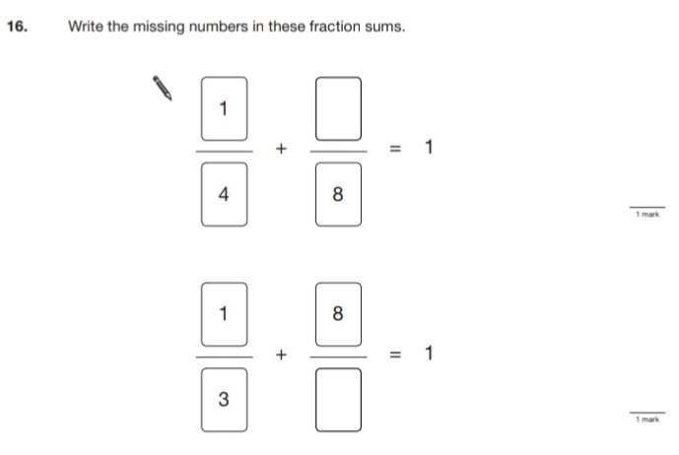
22.
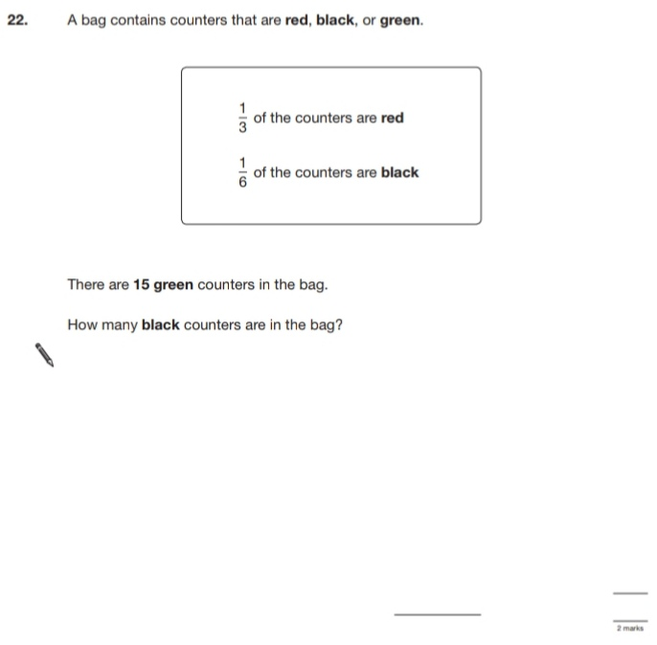
Key Stage 3: 2007 Paper 1 Level 6-8
23.
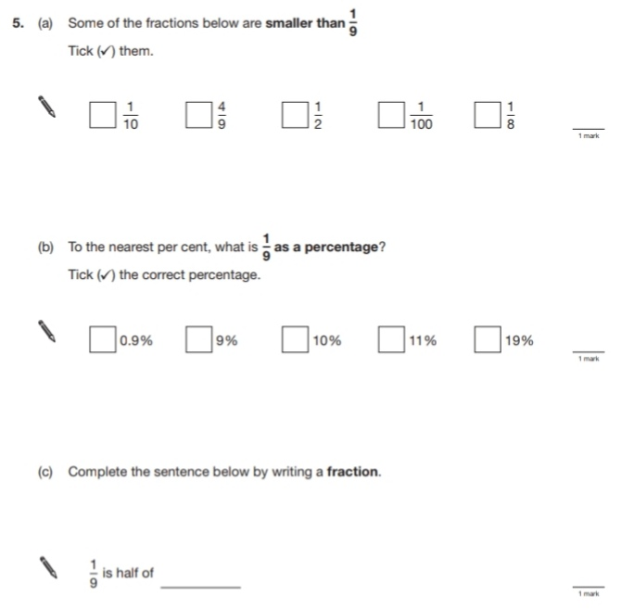
24.
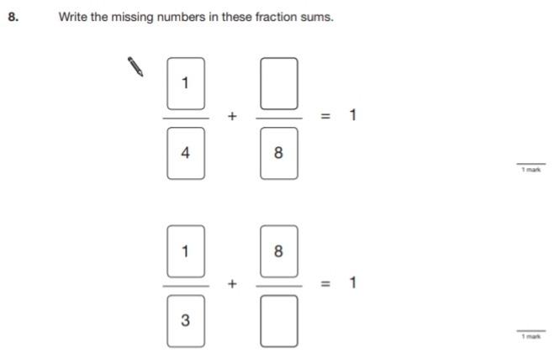
25.
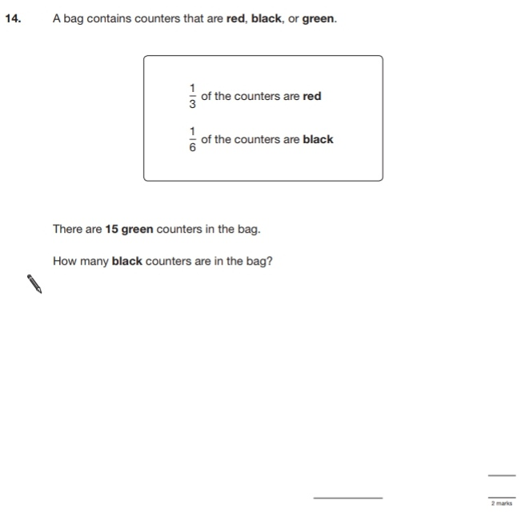
Key Stage 3: 2008 Paper 1 Level 5-7
26.
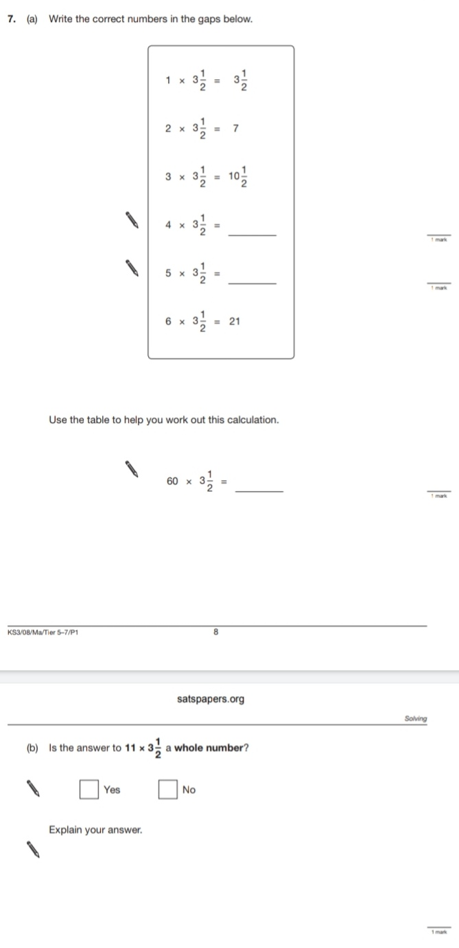
27.
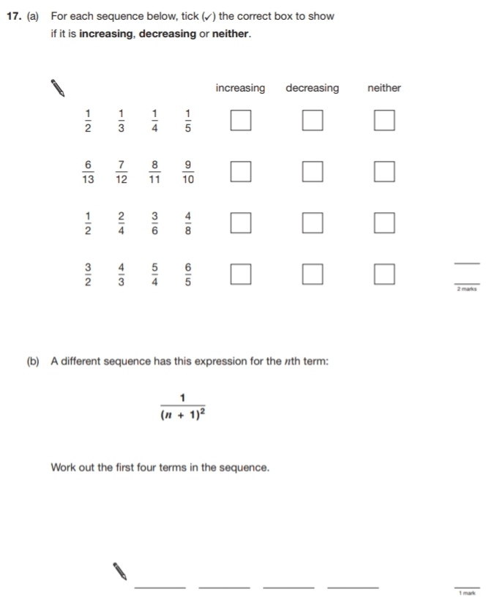
28.
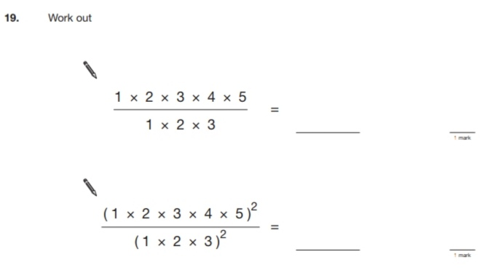
Key Stage 3: 2008 Paper 1 Level 6-8
29.
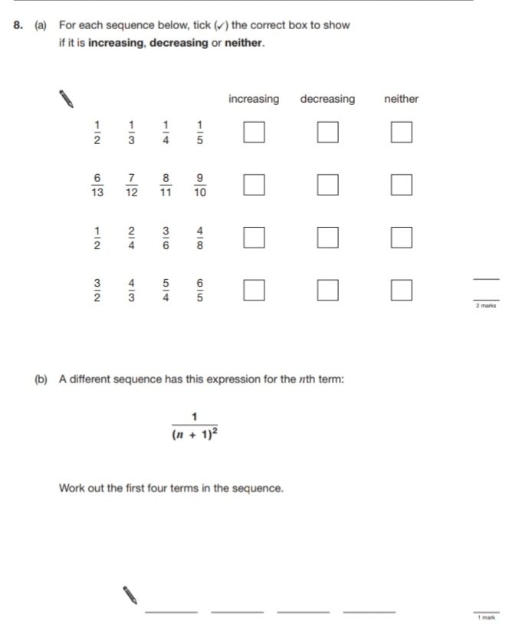
30.
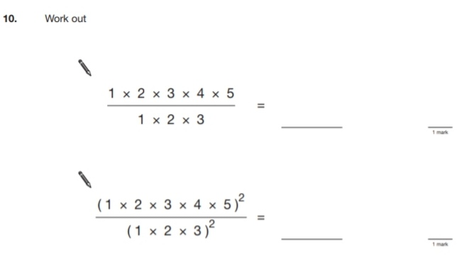
Key Stage 3: 2009 Paper 1 Level 5-7
31.
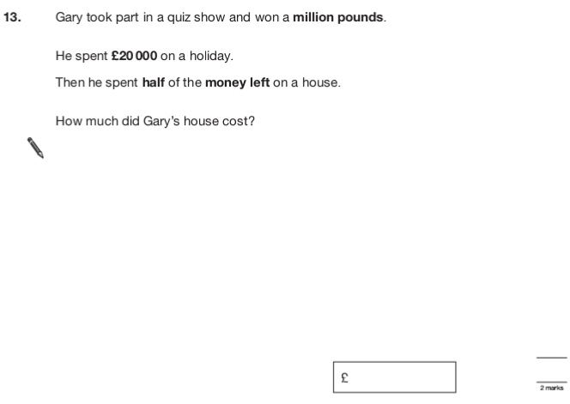
32.
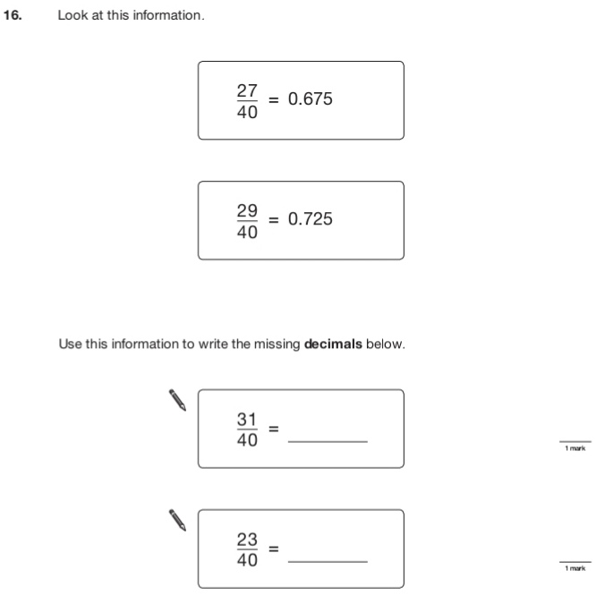
Key Stage 3: 2009 Paper 2 Level 5-7
33.
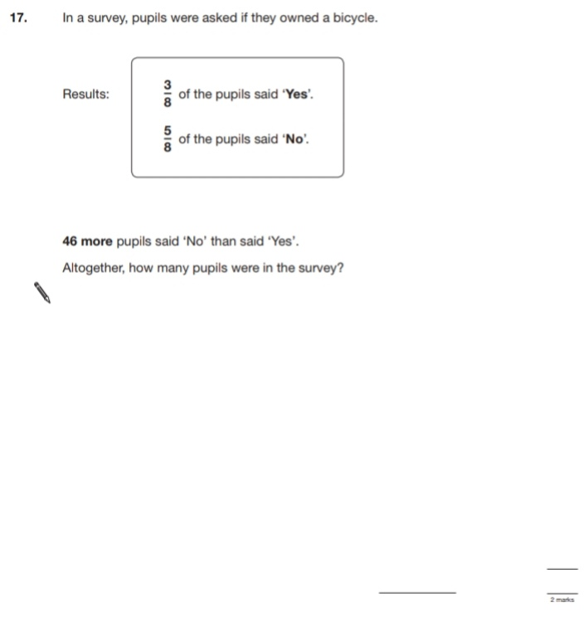
Key Stage 3: 2009 Paper 1 Level 6-8
34.
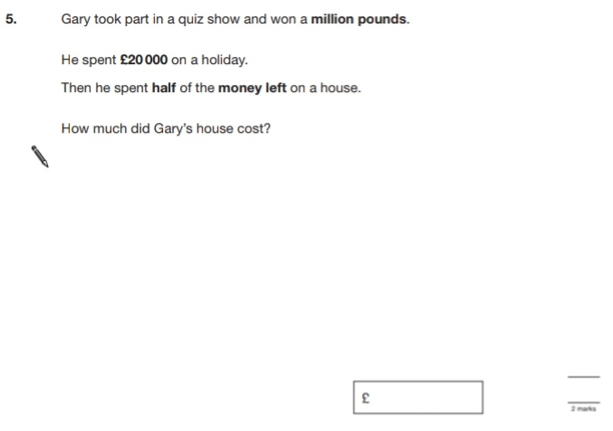
35.
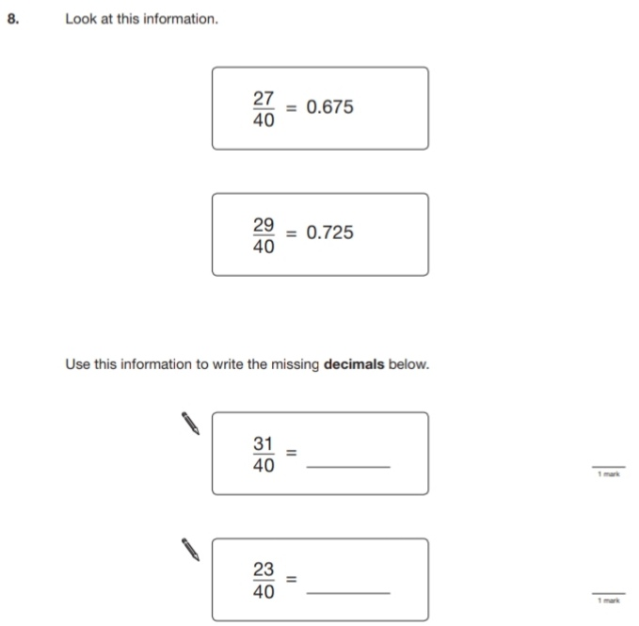
Key Stage 3: 2009 Paper 2 Level 6-8
36.
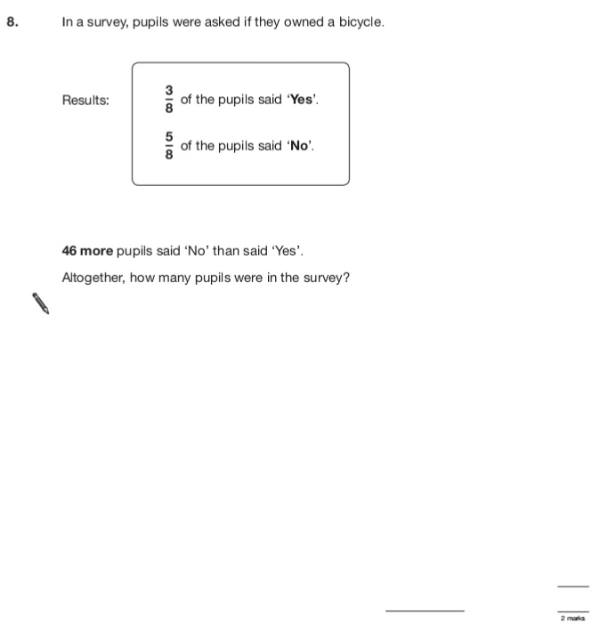
Key Stage 3: 2010 Paper 1 Level 5-7
37.
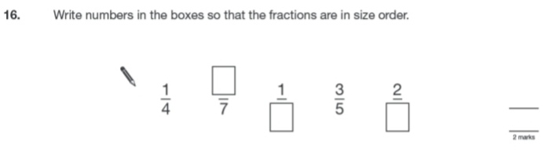
Key Stage 3: 2010 Paper 2 Level 5-7
38.
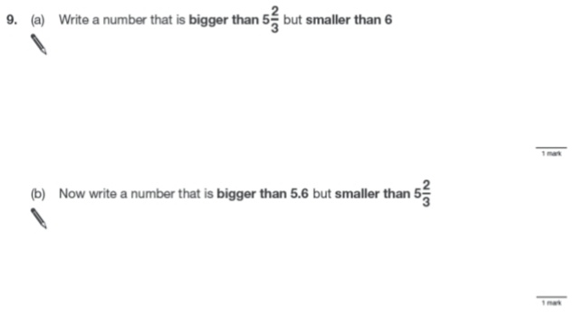
Key Stage 3: 2010 Paper 1 Level 6-8
39.
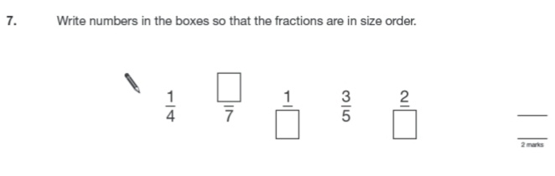
40.
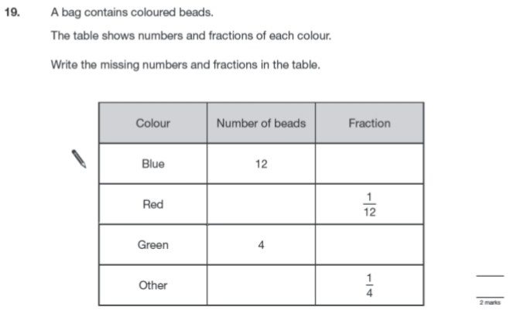
Key Stage 3: 2011 Paper 1 Level 5-7
41.
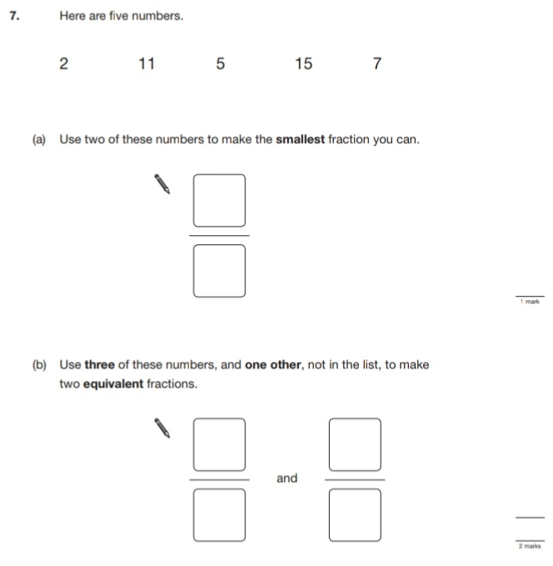
42.
